**Assembly Instructions and Troubleshooting Guide**

1. Overview

This document provides instructions on how to build the open-source CICLoPS photometry system with explicit reference to the appropriate design files provided. CICLoPS assembly instructions is structured around three subassemblies: the optical subassembly, the lock-in amplifier subassembly, and the acquisition/analysis subassembly. These sections are largely independent of other subassemblies; meaning that they can be developed and tested in parallel if necessary.

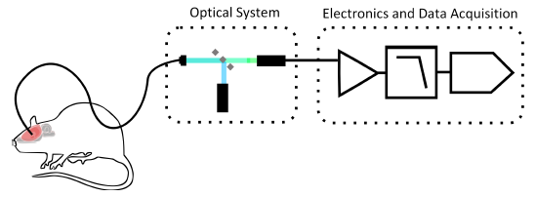

Throughout this document, the following symbols are used:

|  |  |
| --- | --- |
| Symbol | Meaning |
| Free vector graphic: Wrench, Hardware, Tool, Workshop - Free Image ... | tools needed to complete the subassembly in a given section |
| Free vector graphic: Attention, Warning - Free Image on Pixabay ... | common problems and causes |
| File:Green check.svg - Wikimedia Commons | verify that the subassembly is working properly before moving on |

1. Subassembly 1: Optical system

The major components of the optical system are the excitation light source, the PMT detector, the optical tether, and the dichroic mirror. A light-tight cage cube system with lens tubes houses collimating, coupling, and focusing lenses while isolating the system from stray light. The time to build the system is approximately 8 hours.

 **Tools needed**

Drill press

Drill bits: ⅜ “, ⅝ “, $\frac{5}{16}$”

1” hole saw

Wire stripping tool

Soldering iron

Solder

Alan key $\frac{1}{16}$”

SPW602 spanner

½” spanner

Terminal block screwdriver

Current source

Optical Power Meter (PM-100 USB)

White light source (such as a flashlight)

Oscilloscope

Multimeter

Computer

* 1. LED Light Source

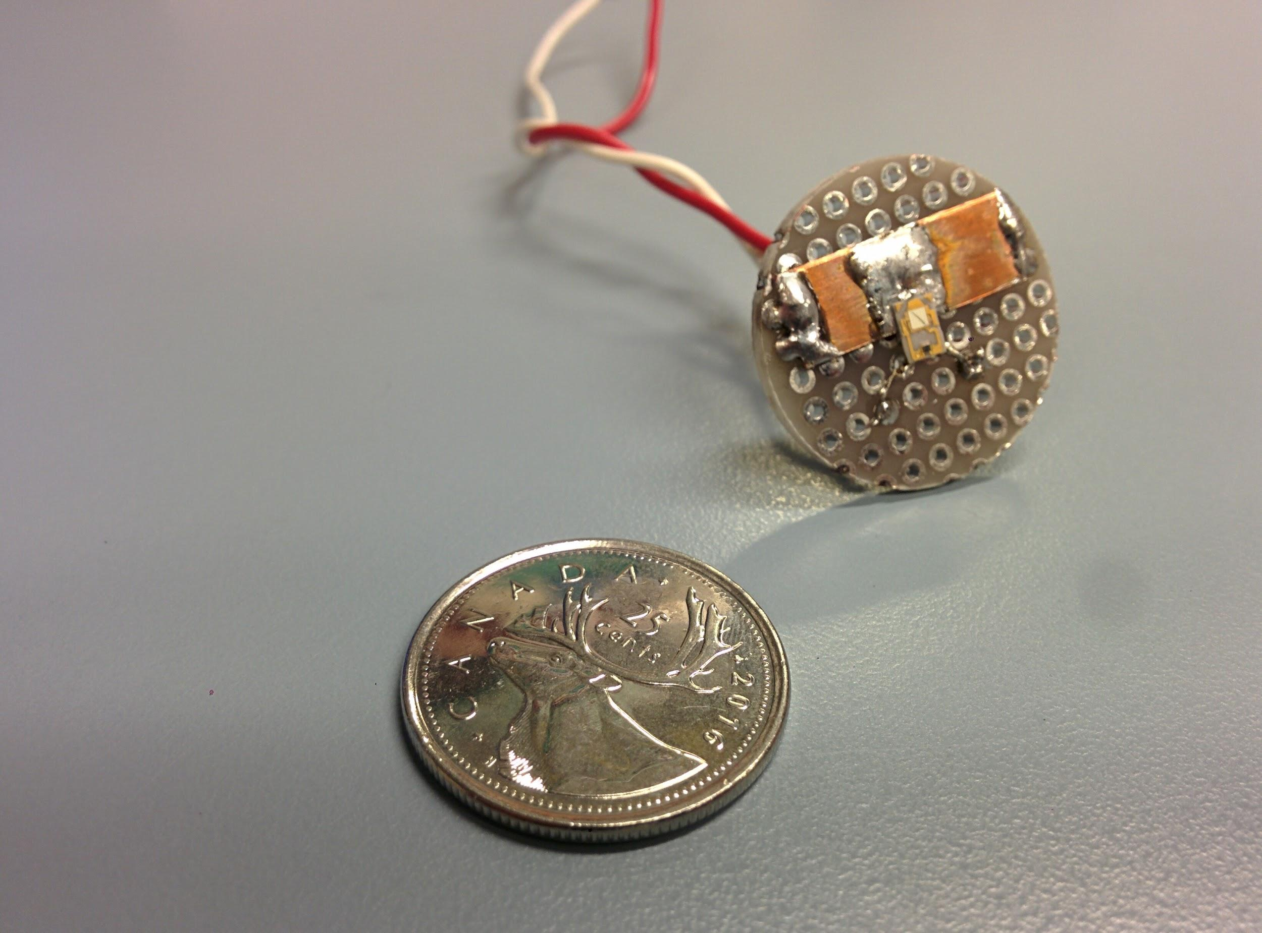

The light source is based off of a simple surface mount LED (*LXML-PB02, Lumileds*). To make this part, first fabricate the LED plate by cutting a 1”-diameter hole into perforated prototyping board, using a drill press and a 1” hole saw. Solder the LED to the plate such that the die is centered (as shown on the left, with an optional heat-sink made from copper shim). Remove the lens from the LED by carefully heating the lens with contact from the soldering iron tip and light pressure. Cut 2- 12” lengths of wire wrap (*R-30B-0050 (blue) and R-30W-0050 (white), Jonard Tools*), stripping ¼ -inch from the tips. Solder one wire to each of the LED pads and thread through the vias. Twist the wire wraps together. The LED may now be powered with either a continuous or modulated current source.

**LED Light Source**

The LED light source power should vary linearly with the current flowing through it, as seen in this chart. Mount the LED plate near an optical power meter. Control the current through it and measure the power output.

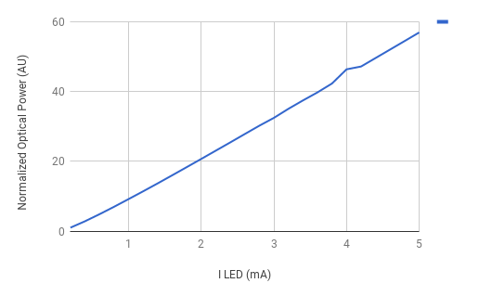

* 1. PMT Detector - High Voltage Power Supply

The PMT (*H10771, Hamamatsu*) transduces light incident on its photocathode into an electrical current. It will be interfaced directly with the optomechanics to collect photons emitted from the fluorescent sample. The PMT has two coaxial cable leads, for high-voltage negative power supply and the output signal. This section describes the assembly of the high voltage power supply module. This section describes the assembly of the PMT’s controllable high voltage power supply.

**Design Notes:** The design is based on the application in the C4900 datasheet. A voltage divider resistor network prohibits the controlling voltage to exceed 3.3 V, limiting the high voltage output to a maximum of ~830 V. This is within the safe operating region for the selected PMT.

First, make the enclosure according to hvsupply_enc.dae. We recommend a 2” length of 4”x 2” aluminum tubing (*6546K42, McMaster-Carr*) and sheet aluminum to cover the open ends, using 3/8” set screws to secure the end plates. Holes for the jack plug connector, BNC connector, and potentiometer may be drilled with a drill press and $\frac{5}{16}$”, ⅝” , and ⅜“ diameter drill bits, respectively.

Next, make the controllable power supply circuit for the C4900 high voltage power supply from Hamamatsu described by hvsupply_schem.SchDoc. It is implemented on an 1.8” x 3.8” section of perforated circuit board. Leave approximately 3” of stranded wire for each of the **V IN**, **HV OUT**, Potentiometer, and **GND** leads for soldering to the BNC connector, jack plug connector, and potentiometer on the enclosure. Position the rotary potentiometer near its knob’s hole in the enclosure. We recommend providing longer leads for its terminals for ease of positioning.

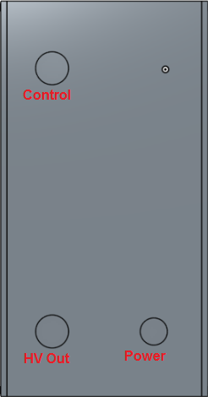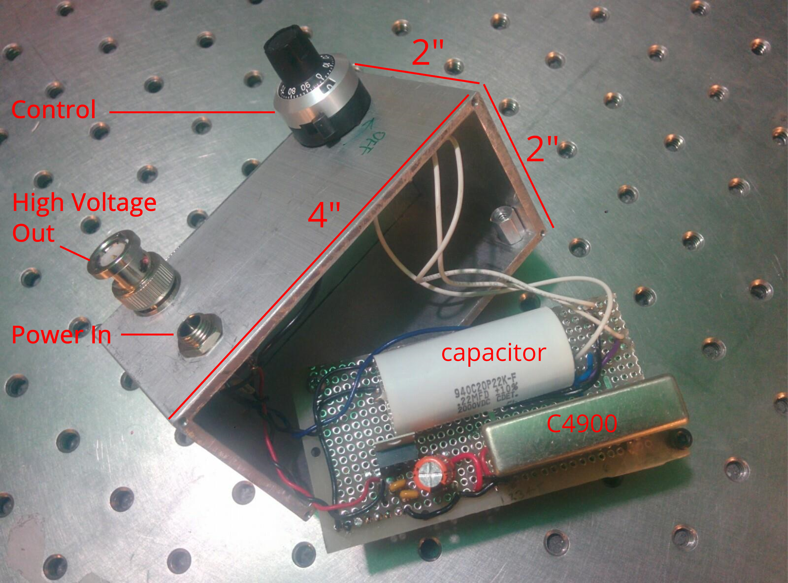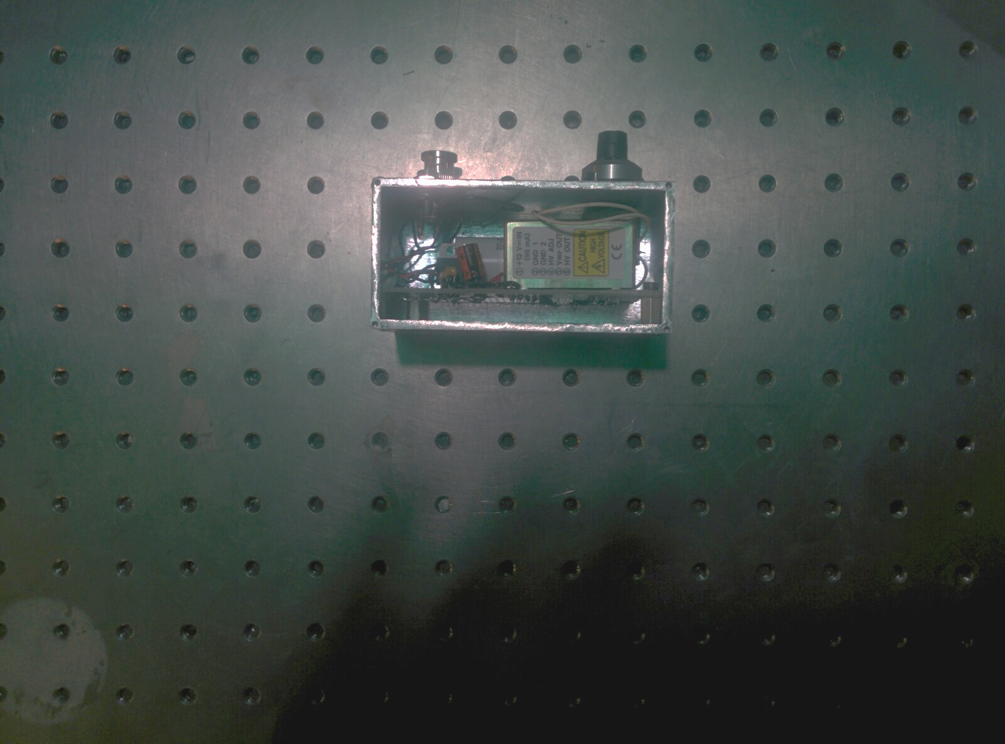

Assembled Controllable Hamamatsu Power Supply. Left: view of enclosure model with designations for panel mount devices. Center: Implemented circuit is removed from enclosure showing leads to panel mount connector. Right, side view of enclosure showing Hamamatsu High Voltage Power supply with end plates removed.

The power supply is ON when it receives +/- 15V power from the wall adapter (WSU150-0560,Triad).

**High Voltage PMT Power Supply**

The high voltage output should vary linearly with the number of turns on the potentiometer, at a rate of ~80V per turn. Use a voltage divider circuit to read HVOUT with a conventional multimeter without surpassing its maximum operating range.

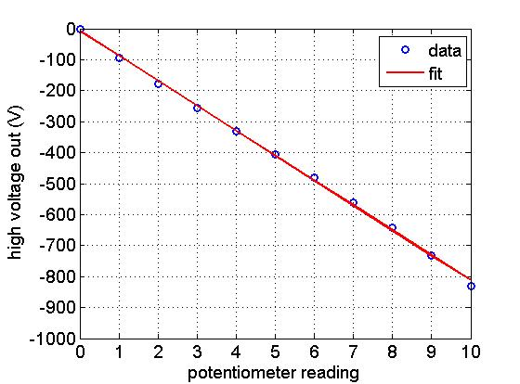

We recommend operating CICLoPS with the HV power supply set to -500 V, or at 6 turns.

* 1. Optomechanics

The optomechanics may be thought of as having an excitation input arm, a fiber tether output arm, and a detector arm that converge on a single cage cube (*C4W, Thorlabs*). The excitation beam is launched into the system via a modulated LED and collimation lens, the spectral profile of which is limited by an excitation filter (*470/40, Chroma Technologies*). This beam is then reflected into the optical fiber tether output by the dichroic filter (*FF495-Di03-25x36, Semrock*). After interacting with the sample, a mix of reflected excitation and fluorescent photons travel back to the system via the optical tether, and are separated at the dichroic mirror. In the detection arm, the beam’s spectral properties are narrowed again by the emission filter (*FF01-504/12-25, Semrock*) and then focused onto the PMT detector by the focusing lens (*AC254-040-A, Thorlabs*).

The accurate model of the optical system (optical_system_assembly.dae) contains exact relative positions between components in the optical system. We recommend that the builder first familiarize themselves with this model and ensure they have all parts before getting started. We recommend building outward from that cage cube one ‘arm’ at a time, as explained here. CICLoPS is an Imperial setup and is not compatible with metric optomechanical parts.

Design Notes: The use of the cage system drastically simplifies the task of aligning the beam. The use of lens tubes reduces the amount of stray light that leaks into the optical system, but does not eliminate the leakage entirely. We recommend covering the system with blackout material (BK5, Thorlabs) during experiments.

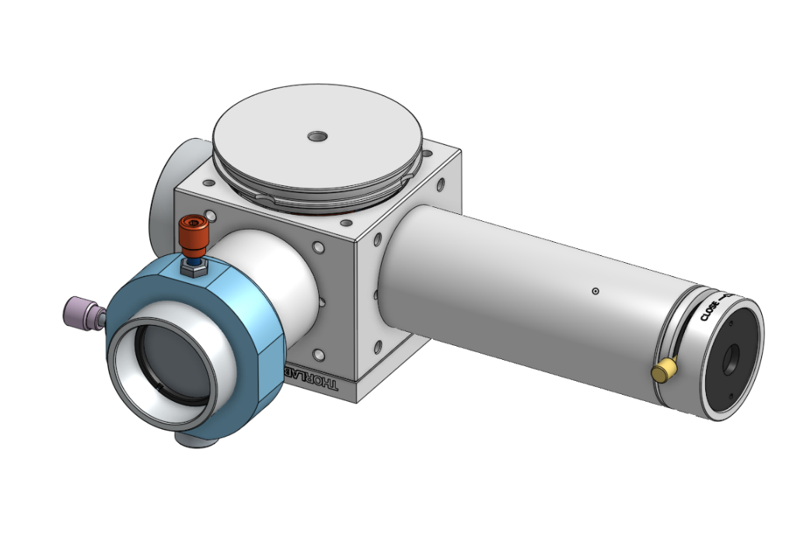

***Excitation input arm***

First, build the collimation assembly. Screw a 0.5” retaining ring (SM05RR) into the into the 1” - 0.5” adapter (*SM1A6T, Thorlabs*), such that it is flush with the other end of the adapter. Place inside the focusing lens, such that the flat surface touches the retaining ring. Place inside the neutral density filter (ND504B, Thorlabs), and secure with a second retaining ring. Next, use the 1/16” Alan Key to position the adapter within the 1” lens tube (*SM1L10, Thorlabs*), ensuring the convex surface of the lens faces away from the retention lip of the lens tube. The distance between the adapter and the mouth of the lens tube should be 10 mm. Use the spanner wrench to check that the adapter itself is positioned 10 mm from the mouth of the lens tube. Next, position the excitation filter (*ET470/40x, Chroma Technologies*), ensuring that it is oriented properly (the arrow on the side should point away from the retention lip, as this is away from the light source) and secure with a retaining ring. Use a lens tube coupler (SM1T2), to fasten the collimation assembly onto anyone of the four 1” tapped holes. Ensure the lens tube coupler makes contact with the closest retaining ring.

Finally, build the excitation assembly. Place the LED plate into the mouth of a 0.5” lens tube (*SM1L05, Thorlabs*) and secure with a retaining ring. Fasten the excitation assembly onto the translation mount.

***Fiber tether output arm***

Secure the collimation package (*F240FC-532, Thorlabs*) into its adapter (*AD12F, Thorlabs*) with the set screws and the allan key. Screw the adapter all the way into the 0.5” lens tube (*SM1L10, Thorlabs*) such that it touches the retention lip. Secure in place with a second retaining ring (*SM1RR, Thorlabs*). Fasten the fiber tether output arm onto the cage cube, 90 degrees to the left of the excitation input arm.

Next, build the dichroic mirror (*FF01-504/12-25, Semrock*) assembly. Pull a gap between the spring-loaded clamping mechanism of the filter mount (*FFM1, Thorlabs*) and place the dichroic mirror in between. Gently release the clamping mechanism. Next fasten the filter mount onto the cage cube platform (*B3C, Thorlabs*), and place into one of the 2” untapped holes of the cage cube. Rotate the platform such that the dichroic mirror is at a 45 degree angle to both of the arms, so that light from the excitation is reflected into the output arm (reference the guide at Semrock to determine how to orient the dichroic mirror [2]). Fasten the FC/PC connected end of the 400 μm optical fiber tether (*MFP_400/440/900-0.53_3m_FC-MF2.5, Doric Lenses*) onto the mating end of the collimation package.

 **Collimation package keeps turning when attempting to connect FC/PC connector.**

Possible cause: Set screws on adapter for collimation package (*AD12F, Thorlabs*) are missing and/or not tight enough, OR the retaining ring (*SM1RR, Thorlabs*) was forgotten.

**Delivery path alignment**

To test for alignment of the beam, supply the LED with 2 mA of continuous current from a current source. Using the optical power meter, check the excitation output of the fiber tether. The dichroic will be at the desired 45 degree angle when the the output is maximized. If the model is built as specified, the system will output 1.25 μW when the LED is supplied with 2 mA of continuous current.

***Detection arm***

First, attach BNC connectors onto the lines of coaxial cable on the PMT according to the guide at Cable Organizer [3]. Use a free-hanging male connector (*031-4321, Amphenol*) for the **PMT OUT** and **GND** line, and a free-hanging female connector (*031-317, Amphenol*) for the **HV IN** and **GND** line.

Place the emission filter (*ET504/12, Semrock*) all the way into the 3” lens tube (*SM1L30, Thorlabs*) to the optic retention lip and secure with a retaining ring. Using the spanner wrench, fasten another retaining ring 30.5 mm into the lens tube, and place the focusing lens (*AC254-40-A, Thorlabs*) adjacent to it, ensuring the convex surface of the lens faces the retention lip of the lens tube. Secure with another retaining ring. The distance between this second retaining ring and the mouth of the lens tube should be 21 mm. Use the spanner wrench to check the position. Fasten the shutter (*SM1SH1, Thorlabs*) and then the PMT onto the detection assembly using epoxy (Plastic Bonder, JB Weld). Finally, fasten the detection assembly onto the cage cube, into the tapped hole opposite that of the output detection arm. Fasten the end cap (*SM1CP2, Thorlabs*) on the last tapped hole.

**Emission path alignment**

After disconnecting the shutter and PMT from the optical system, feed white light into the output of the optical tether (for example, with a flashlight) such that it propagates back to the system. The spot 1” from the mouth of the remaining detection arm should be 3 mm in size.

**Optical System**

The optical system comprises the light source, the optical fiber tether, the PMT, its high voltage power supply, and the optomechanics that manipulate the beam and its path. In a dark room with lights off (to avoid damaging the PMT), perform the following test:

Use a current source to drive the LED and simultaneously measure the optical power output at the optical fiber (with the optical power meter) and the current output of the PMT (plug the signal line into an oscilloscope). The optical fiber contains endogenous fluorophores that will provide a source of fluorescence for this test.

1. Set the High Voltage power supply to -550 V
2. Step the current source in 0.2 mA increments
3. Record the optical power at the output of the optical fiber, and the signal from the PMT

This test reveals the relationship a linear relationship between the LED current and the optical power, which in turn is linearly related to the PMT signal. Note that the PMT provides increasingly negative signal values with increasing optical power, as its signal current is carried by electrons.

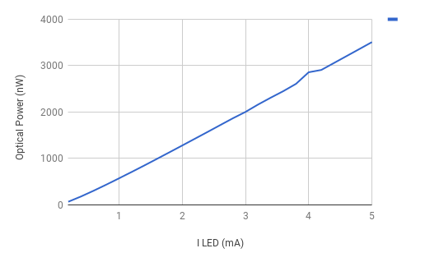

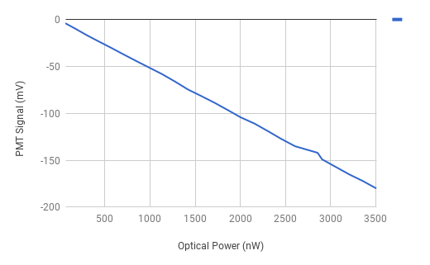

1. Subassembly 2: Lock-in Amplification Scheme

The lock-in amplifier provides immunity to uncorrelated noise sources by modulating the excitation

of an experiment at some carrier frequency, fc. The limiting factor in the LIA’s output range is the input to the multiplier (*AD633, Analog Devices*). Its input common mode range is 10 V, meaning that a maximum of 100 nA may be converted to a voltage by the TIA with the gain of 100 as designed.

 **Tools needed**

Soldering iron

Vice

Drill press

Drill bit ⅜ “

Tweezers

Solder wick

Function Generator

Laboratory Labeling Tape (*89097-934, VWR*)

10 x 1M through-hole resistors

Prototyping breadboard

Access to a dark room

High speed photodiode (like PDA36A)

Oscilloscope

For the LIA enclosure, we recommend using a 1.625” length of 1.5” x 1.5” ¼”-thick aluminum tubing, and using 1.5”-square sections of aluminum sheet as end plates. Similar to the PMT enclosure, secure the end plates with set screws. Drill 3-⅜ “ holes into the top of the box as shown below for signal lines. Drill 1-⅜” hole into the side to thread lines for power and the LED.

Next, populate the fabricated lock-in amplifier PCB (specified in pcb_layout.PcbDoc) as shown in pcb_assembly.pdf. The regulator on the bottom of the PCB will prevent contact with the enclosure. Use 2” lengths of wire wrap to provide signal lines for **SIG OUT**, **MOD**, and **PMT IN.** Solder these to their respective female BNC connectors (*31-221-RFX, Amphenol RF Division*) and then secure to the enclosure. Cut 2-12” lengths of wire wrap for LED current (use different colors to denote anode and cathode terminals) and 3-12” lengths of stranded wire to connect to the battery pack (again using different colors to denote **VBATT+**, **GND**, and **VBATT-**). Solder a male 3-pin header (*61300311121, Wurth*) onto the 3 power supply leads, and a female 2-pin receptacle (*PPPC021LFBN-RC, Sullins*) onto the LED leads. Isolate adjacent solder joints with electrical tape.

Make BNC cables for **MOD** and **SIG OUT** by cutting one male-to-male BNC cable in half (*115101-02-24.00, Amphenol*). Strip ¾ ” from the end of each cable, and then another ½” from the foam jacket. Separate each of the braided wires and twist together. Tin the ends of both the braided wires and the center wires to make ground and signal lines.

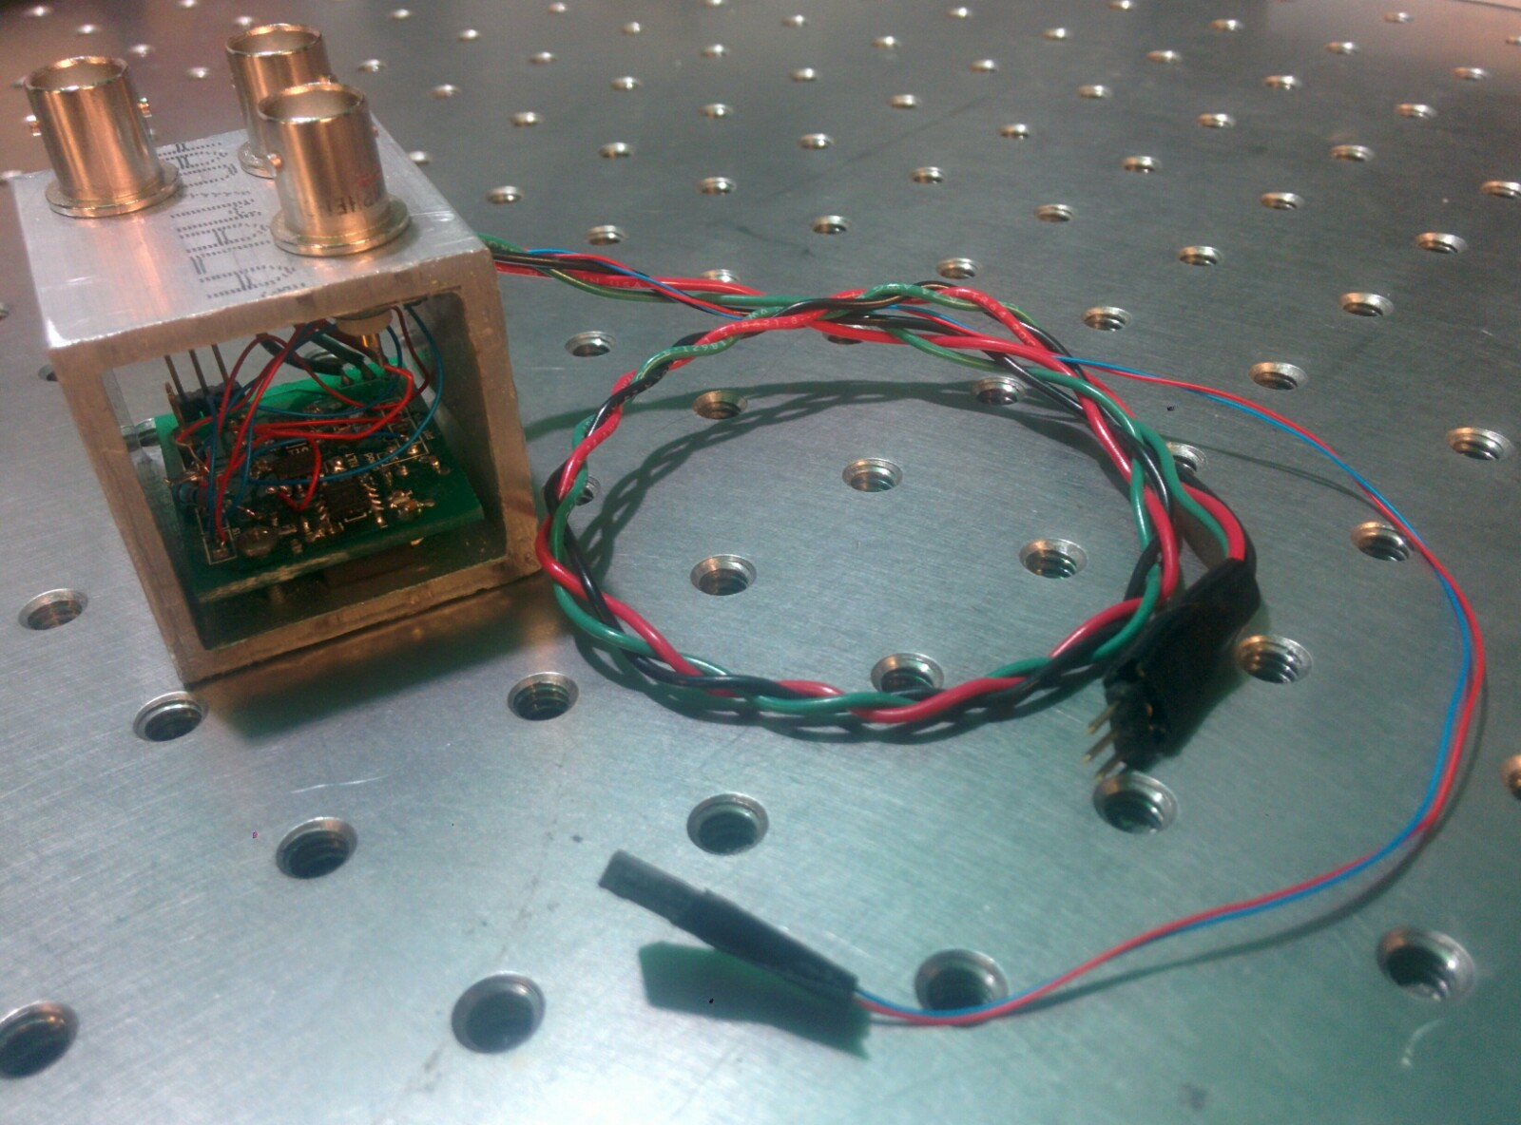

**Optical Modulation and Demodulation using the Lock-in Amplifier**

A number of tests should now be undertaken to develop an intuitive understanding of CICLoPS and its LIA. We recommend performing these characterizations in a dark room, with access to an oscilloscope, function generator, power meter, amplified photodiode, and BNC cables.

1. First, use the amplified photodiode (*PDA36A, Thorlabs*), an oscilloscope, and a function generator to verify the functionality of the LED driver. Set the function generator to produce a 7.5 V amplitude (peak-to-peak) 100 Hz sine wave, and connect to **MOD**. Connect the LED terminals to the **LED OUT** terminals. Mount the LED plate to photodiode via a 1” lens tube, and connect the amplified photodiode to an oscilloscope via a BNC connector. The detected light should be modulated at the same frequency and have -30 dB distortion. Note that this detected signal, unlike the modulation waveform, does not go below zero as light can only be detected in positive quantities.

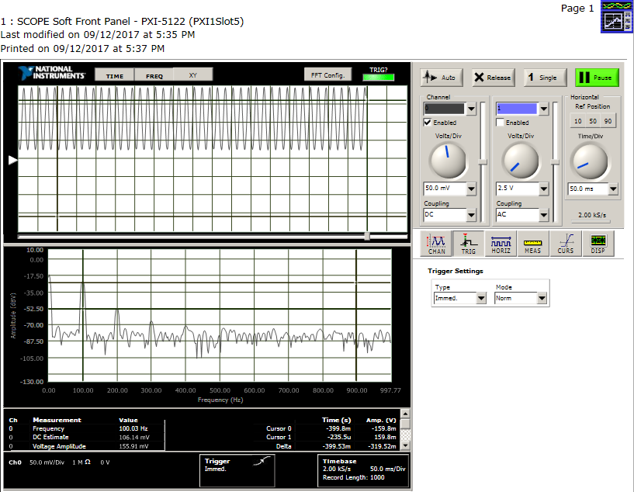

Next, monitor the outputs of the TIA. These tests requires you and the system to be in a dark room location, as the PMT will be ON. The PMT is extremely sensitive to light; exposure to room lighting will damage it.

1. **a)** Ensuring the shutter to the PMT is closed, turn on the HV PSU and set to -550 V. Fasten the LED plate back into the excitation arm assembly as specified above. Connect the oscilloscope probe to the TIA outputs (marked as TIA out on the PCB) and use the function generator to provide a 7.5V pk-pk, 100Hz **MOD** signal. Tape laboratory labelling tape (*89097-934, VWR*) to a surface near the optical fiber tip. This tape will act as another source of fluorescence to investigate the instrument’s dynamic range. Open the shutter to the PMT. The signal that appears on the oscilloscope should be the same frequency as that provided by the function generator. Now place the optical fiber cannula near the tape. The amplitude of the received signal should increase as shown in the figures below.

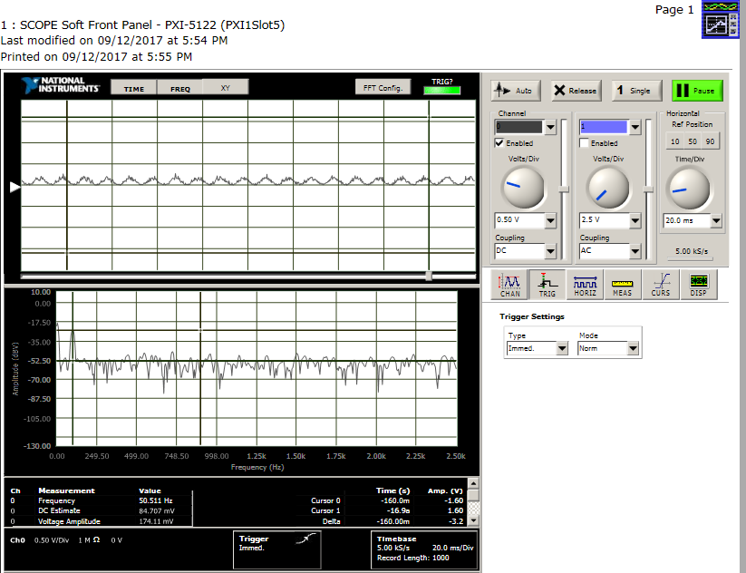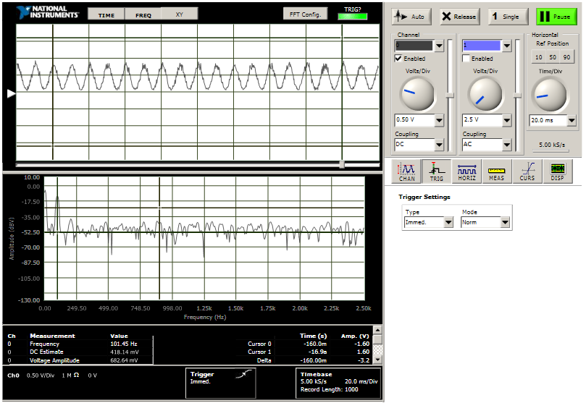

1. **b)** Repeat (a) with HV OUT set to -640 V. The amplitude of the received signal should be larger, and the waveform should clip when the optical fiber tip is placed on the tape.

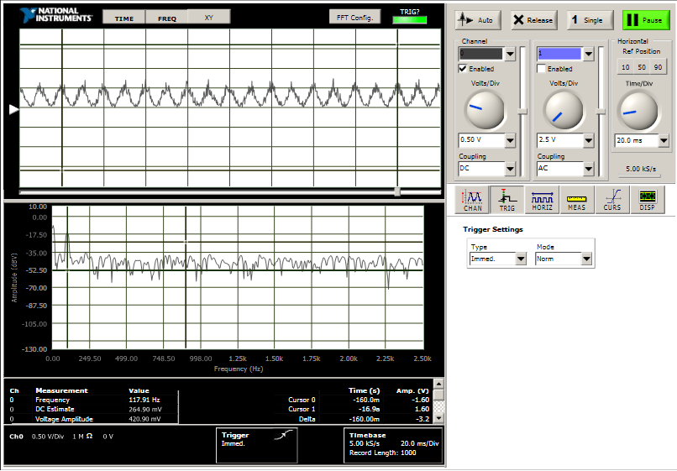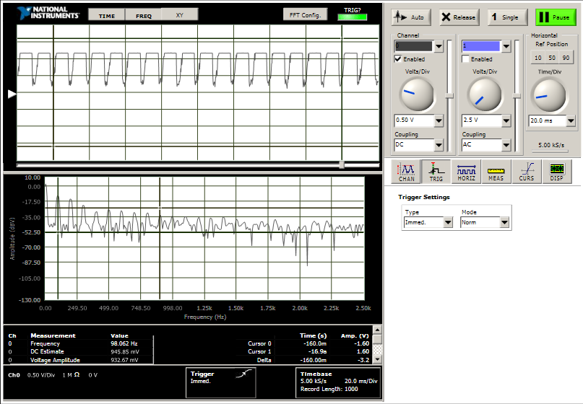

1. Finally, monitor the output of the LIA, continuing to work in the dark room location with lights off. Connect a BNC cable from **SIG OUT** to an oscilloscope. As the output from the LIA is a demodulated value, the oscilloscope should provide a DC reading. Measure the resultant signals from the fiber alone and from the tape with **HV OUT** set to -550 V, and the resultance signals when **HV OUT** is set to -650 V.

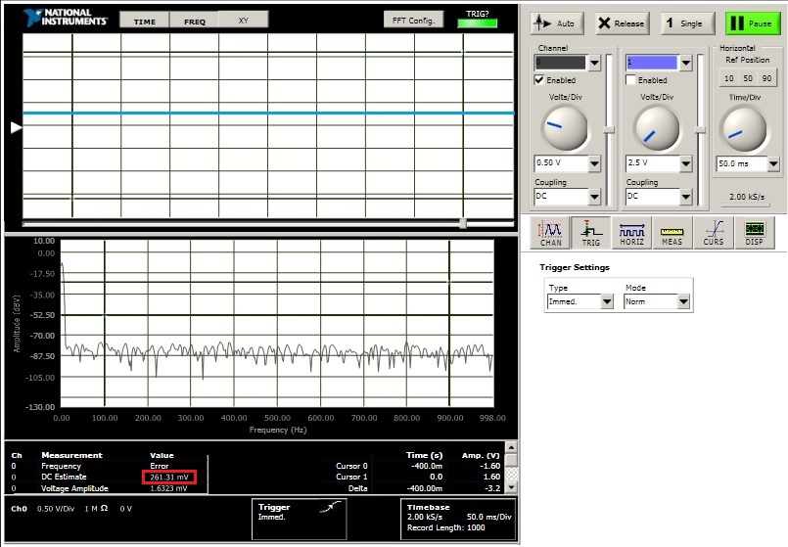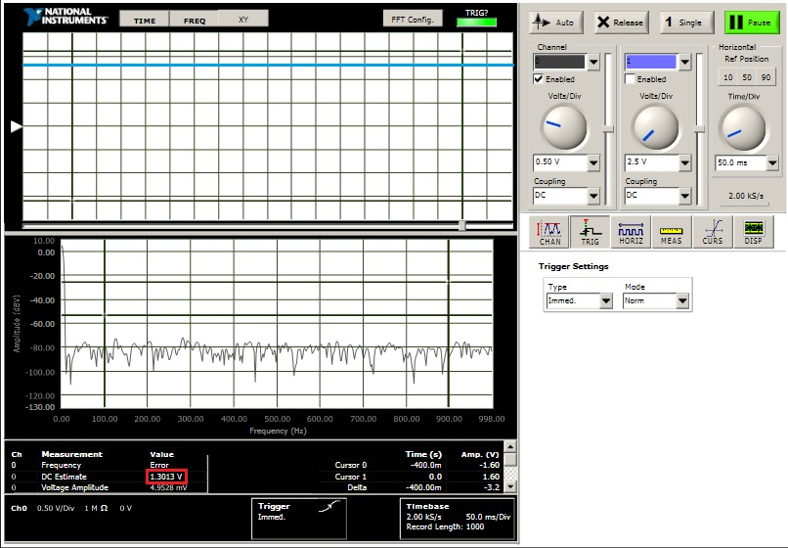

Signals acquired from endogenous fluorescence from fiber (left) and from fiber and tape (right) with HV OUT set to -550 V. A 400% increase in detected fluorescence intensity is observed with the tape.

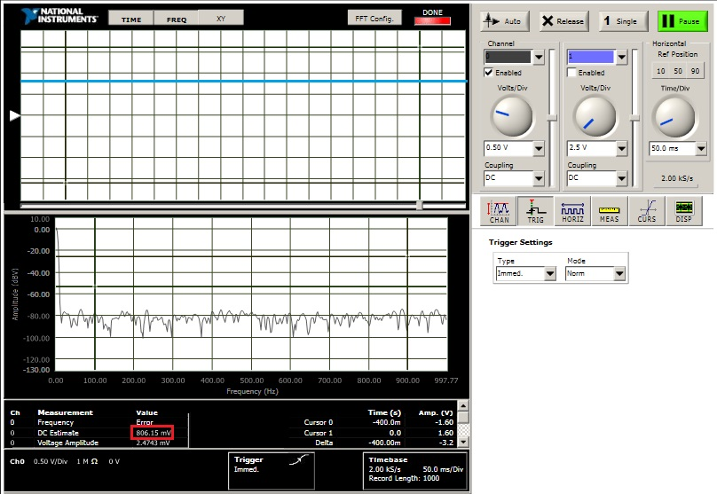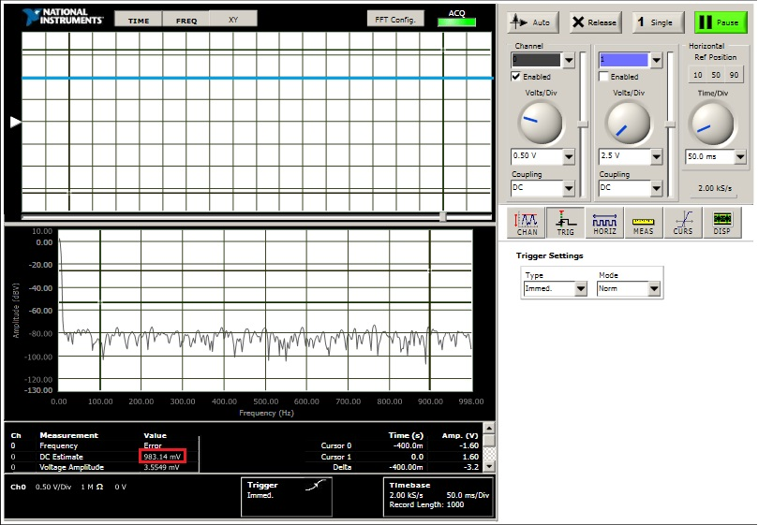

Signals acquired from endogenous fluorescence from fiber (left) and from fiber and tape (right) with HV OUT set to -640 V. The TIA is saturating, and only a 22% increase in detected fluorescence intensity is observed with the tape.

1. Subassembly 3: Software
   1. Data Acquisition

Both modulation/demodulation and acquisition of analog data are accomplished with the data acquisition card (*USB-6351, National Instruments*), using its analog output and analog input, respectively. The daq operations are provided by C++ code developed in Microsoft Visual Studio. The v_write solution enables acquisition of analog data, while lockin_amplifier controls the modulation/demodulation scheme. To collect data coherently, start the lockin_amplifier first (open Lock-in Amplifier.sln), and then begin acquiring data (V_Write.sln).

Other Libraries/Software Tools to install:

1. Allegro: This low-level graphics library was used to generate the real-time display of data. The link to download and installation instructions are available in references [5].
2. National Instruments: NI DAQmx drivers and ANSI C Libraries [6]. These are proprietary resources that require an account with National Instruments to download.

Be sure to add the directories of these files to the Include and Library Directories, accessible through the Property Pages > Configuration Properties > VC++ Directories Dialog.

Design notes: The modulated voltage waveform generated by lockin_amplifier and the daq has offset of zero and amplitude of 3. This is the maximum amplitude given the daq’s output range. This waveform is fed directly to the op-amp LED driver. The acquisition range on the daq is set to [-1,1], which is good match to the maximum output range of the lock-in amplifier [0,1.25].

lockin_amplifier

The solution generates a terminal window for user input. The user need only accept each of the prompts to begin generating the modulation/demodulation waveforms to the lock-in amplifier hardware.

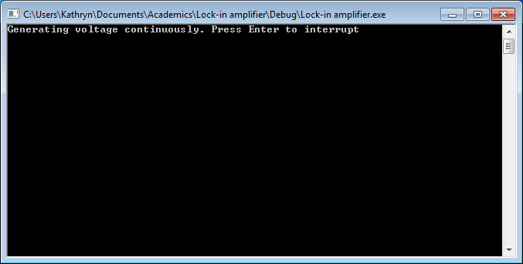

v_write

The solution generates a terminal window that prompts for user input on filename. After accepting the remaining prompts, the window generates a real-time display of the incoming data, with a 100 sample averaging operation applied. The user can modify this display to zoom in (z, Enter), zoom out (o, Enter), or center the trace (c, Enter) about the cumulative average of the collected samples using keyboard inputs to the terminal. Each command must be followed by the channel in question (for example, to zoom in on channel 0, do: z, Enter, 0, Enter)..The experiment can be interrupted at any time (q, Enter). The data is stored in the same folder as the solution in binary values sampled at 100 samples per second.

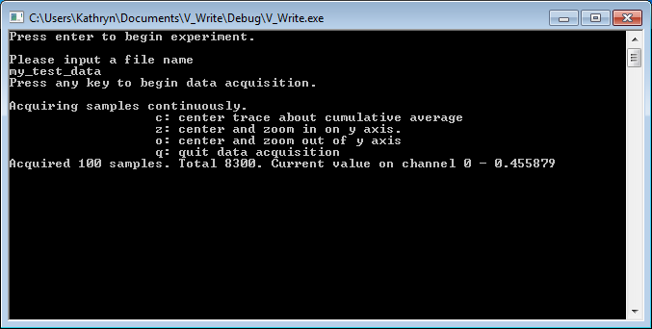

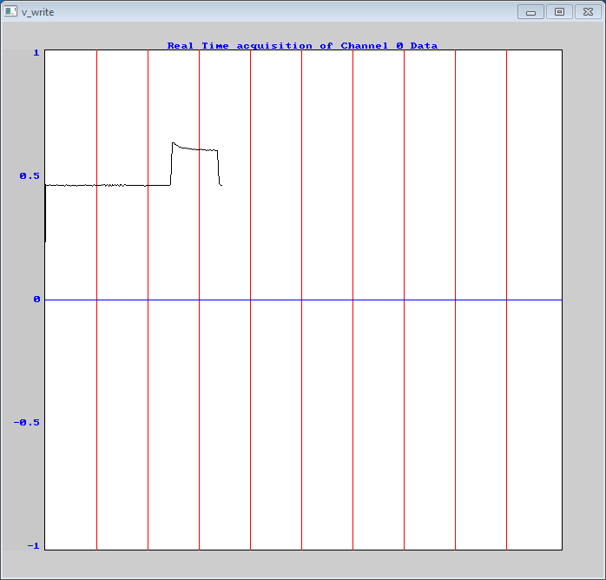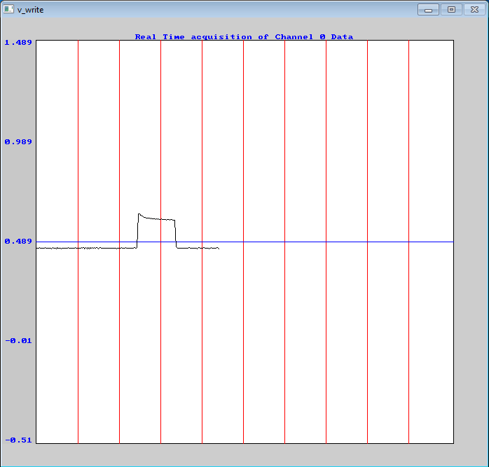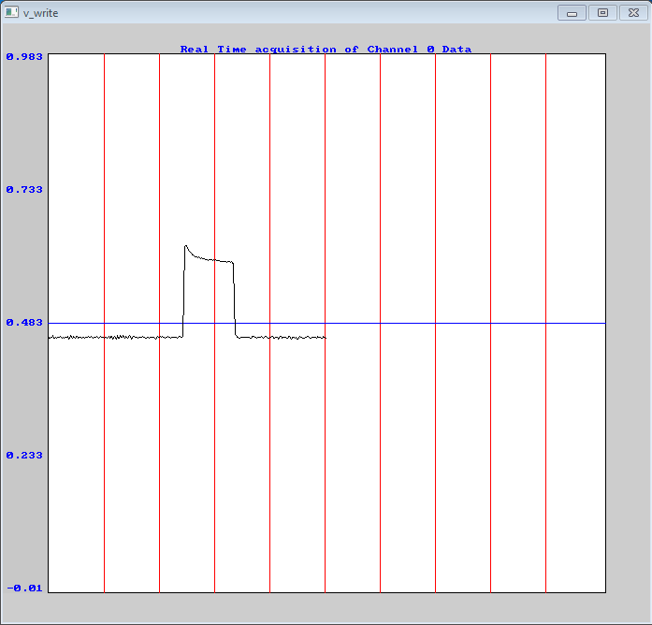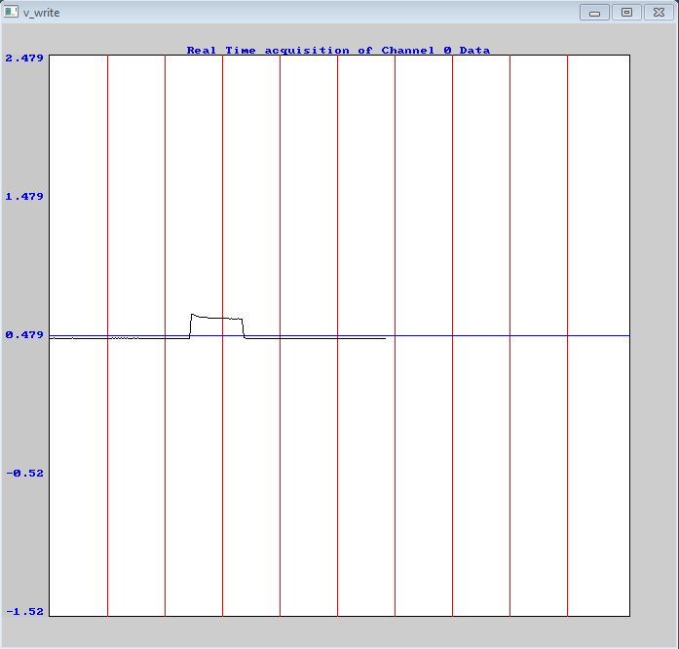

Real-time display of incoming data provided by the v_write solution. From left: Default display, centered display (c, Enter), zoomed-in display (z, Enter), and zoomed-out display (o, Enter).

The acquired data from CICLoPS is written in 16-bit binary values. In any given channel, both the time and Custom Matlab script (binary_read.m) are used to convert the data into decimal values. Example *in-vivo* data is provided to test this code.

**Summary of Settings and Configurations**

|  |  |
| --- | --- |
| **Optical System** |  |
| Excitation Filter | 470/40 nm |
| Optical Attenuation | 0.4 OD |
| Dichroic Mirror | 495LP |
| Emission Filter | 504/12 nm |
| High Voltage Power Supply | -500 V |
| Average Pex | 100 nW (as measured at 470 nm) |
|  |  |
| **Lock-in Amplification Scheme** |  |
| Modulation Amplitude | 3.75 V (peak) |
| DAQ AO channel | AO 0 |
|  |  |
| **Data Acquisition** |  |
| DAQ AI Channel | 1 |
| Acquisition Range | [-1,1] |
| Sample Rate | 100 SPS |
|  |  |

**References**

[1] Hamamatsu Photonics, June 2012. [Online]. Available: <https://www.hamamatsu.com/resources/pdf/etd/C4900_TACC1013E.pdf>.

[2] “Frequently Asked Questions.” *Technical FAQ - Semrock*, [www.semrock.com/technical-faq.aspx](http://www.semrock.com/technical-faq.aspx).

[3] CableOrganizer.com. “How to Attach a Crimp-On BNC Connector.” *Back to Shopping*, www.cableorganizer.com/learning-center/how-to/how-to-attach-a-crimp-on-bnc-connector.html.

[4] Ronayne, Kathryn. *Optoelectronic Systems and Applications for In Vivo Fiber Photometry*. University of Calgary, 2016.

[5] “Welcome to Allegro!” *Allegro - A Game Programming Library –*, liballeg.org/.

[6] “NI Drivers Results.” *Ni.com: NI Hardware Drivers :: Downloads > Data Acquisition*, [www.ni.com/nisearch/app/main/p/bot/no/ap/tech/lang/en/pg/1/sn/catnav:du,n8:3478.41.181.5495,ssnav:ndr/](http://www.ni.com/nisearch/app/main/p/bot/no/ap/tech/lang/en/pg/1/sn/catnav:du,n8:3478.41.181.5495,ssnav:ndr/)